**Project Report for population forecast**

1. **INTRODUCTION**
   1. Overview

The world’s population is more than three times larger than it was in the mid-twentieth century. The global human population reached 8.0 billion in mid-November 2022 from an estimated 2.5 billion people in 1950, adding 1 billion people since 2010 and 2 billion since 1998.

The world’s population is expected to increase by nearly 2 billion persons in the next 30 years, from the current 8 billion to 9.7 billion in 2050 and could peak at nearly 10.4.

billion in the mid-2080s.

This dramatic growth has been driven largely by increasing numbers of people surviving to reproductive age, the gradual increase in human lifespan, increasing urbanization, and accelerating migration. Major changes in fertility rate have accompanied this growth. These trends will have far-reaching implications for generations to come.

* 1. Purpose

Population data contains various influential details such as birth, death, demographic information such as age, sex, annual income, occupation, language, etc. The overall socio-economic, economic, political, cultural progress of a country is dependent on population data to a large extent.

1. **Problem Definition & Design Thinking**
   1. Empathy Map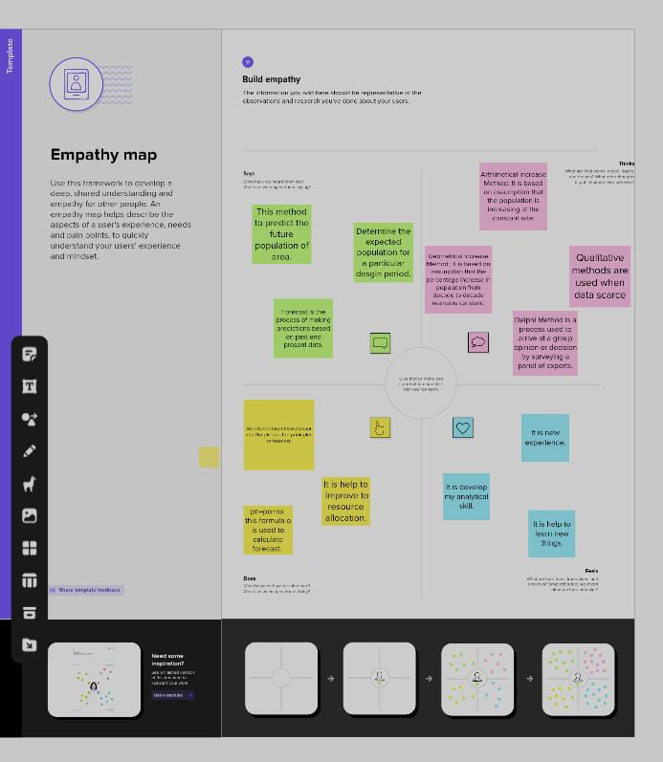
   2. Ideation & brainstorming Map

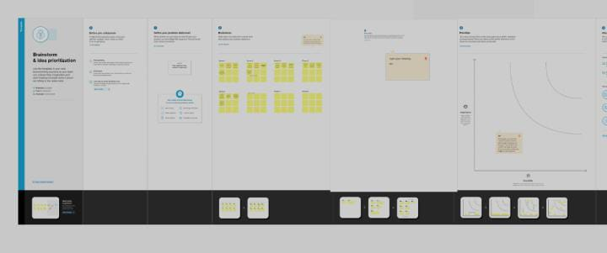

1. **RESULT**

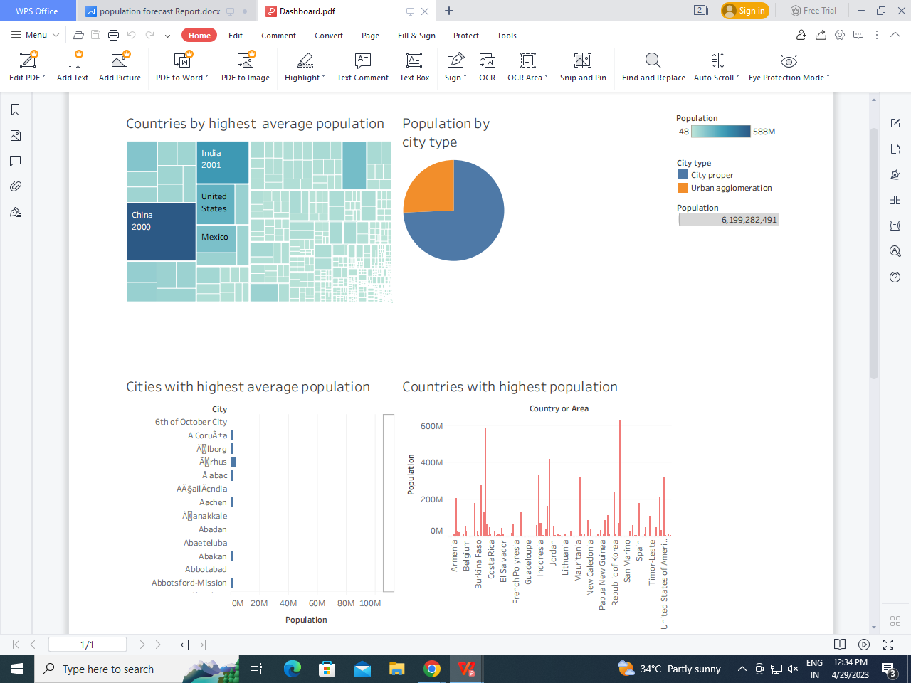

1. **ADVANTAGES & DISADVANTAGES**

Advantage:

In population projection, it is necessary to anticipate the number of persons who will be born and will survive to replace the present generation. There are a number of measurements of birth rates.

Disadvantage:

The reliability of projections decreases over time, and projections tend to be less reliable in periods of rapid change. Projections for areas with small populations tend to be less reliable than those for areas with large populations.

**5 APPLICATIONS**

In future we are in analyst that time we want to analyse the population forecast this solution is applicable.

1. **CONCLUSION**

The entire work for this project is analyse the population year by year . Finding the way to analyse the population forecast by use of this project.

1. **FUTURE SCOPE**

The population of a country or area grows or declines through the interaction of three demographic factors: fertility, mortality, and migration. To project future population, demographers make assumptions about how the current rates of births, deaths, and immigration and emigration will change in the future.